**Screen Recording w/ Zoom Checklist**

1. Download Zoom at zoom.us.
2. Login using credentials.
3. Open Zoom app



1. Click “Start with video”

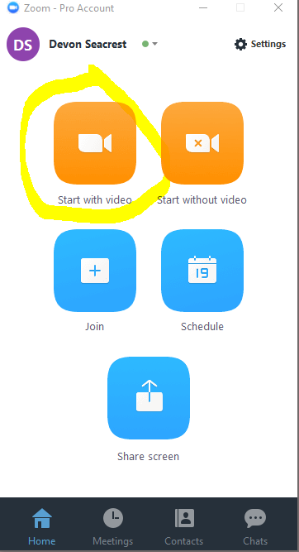

1. Click “Join Audio Conference by Computer”

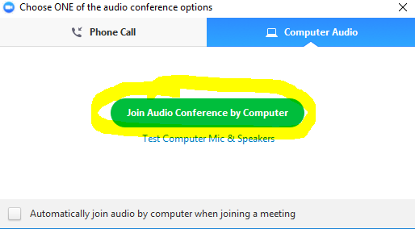

1. Click “record” -> “ to cloud” or “on this computer” and then “Share Screen”

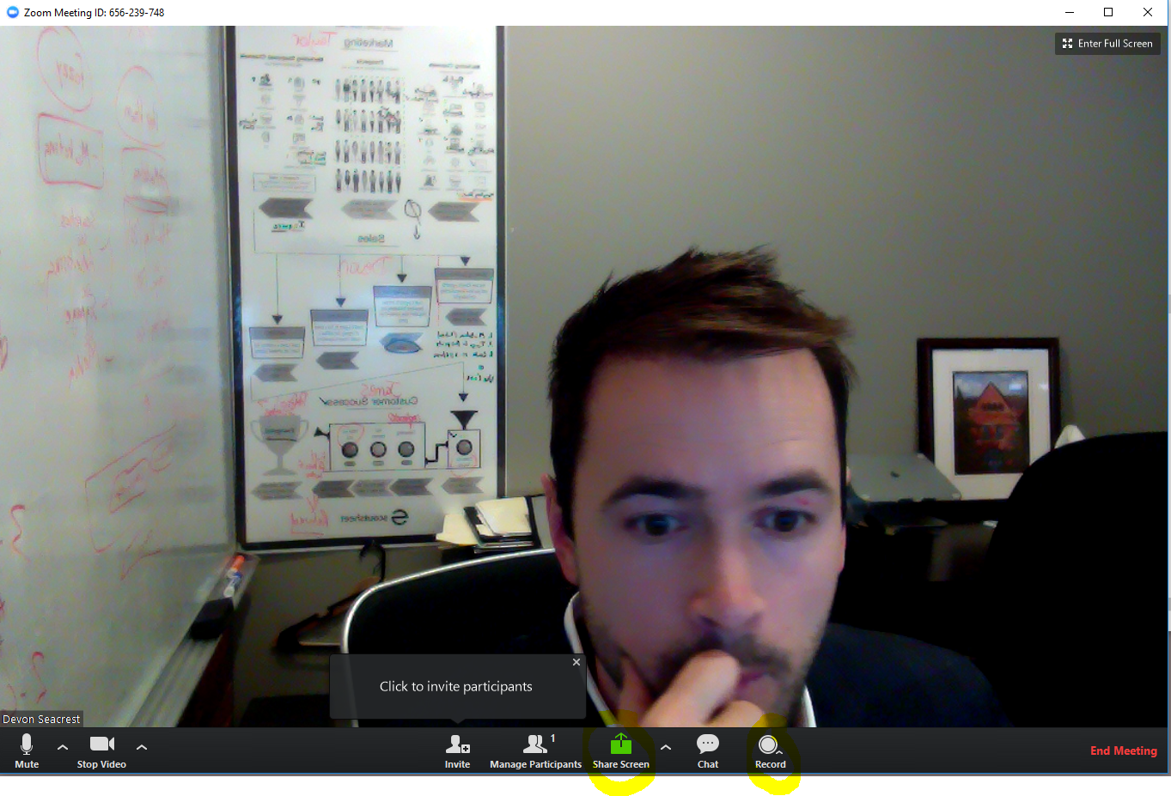

1. Start interview.
2. Click “Stop Share” on panel
3. Click “Stop Recording”
4. Click “End Meeting”
5. To view recordings, click on settings, then Recording tab on left sidebar and see the local storage location or click “Manage my cloud recording”

